The Vine Basket, pre-reading
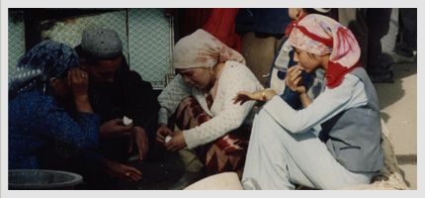
c. Joseanne laValley, joseannelavalley.com/photo_essay.html
Describe what you see in the photo. Use single words and phrases in a list.
What do you think about what you see here?
What do you wonder about what you see in the photo?

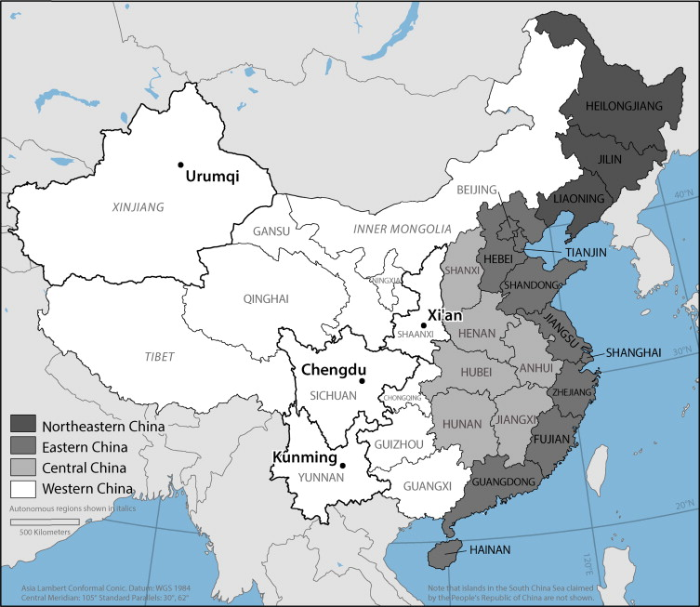

Setting: This novel takes place in Xinjiang, a province in western China. Xinjiang is the home of the Uyghur people. The Uyghur are culturally, ethnically, and linguistically distinct from the majority Han Chinese population. For several years, the Chinese government has conducted an ethnic cleansing campaign against the Uyghurs that includes detention centers, re-education, forced labor, removal of children from their families, and forced sterilization of women.
Character: Mehrigul is the protagonist of The Vine Basket. She is a teenage Uyghur girl living with her family on a farm in Xinjiang province.
Plot: The Vine Basket tells of a Uyghur girl's struggle in a land dominated by the Chinese national government. When fourteen-year-old Mehrigul's brother leaves home she must give up school to help on the family farm. That makes her a prime candidate to be sent to work in a Chinese factory. She alone knows the truth of her brother's departure – and that he will not return. Whether she is sent thousands of miles away or tied to farm work, her future looks bleak. How Mehrigul takes a hand in shaping her destiny is at the heart of a story that celebrates creativity, determination, and dreams (LaValley, 2017).

Characters
As you read, keep track of information about characters and the page numbers where you found this information.
Character Name | Personal Characteristics (appearance, age, abilities, preferences, personality) | Actions | Relationships | Social pressures/ external pressure
Mehrigul
Ata (father)
Ana (mother)
Lali (younger sister)
Memet (older brother)
Chong Ata (grandfather)
Susan Chazen
Abdul (Susan’s guide)
Pati (Mehrigul’s friend)
Hajinsa (Mehrigul’s classmate)

Single Character Reading notes
As you read, focus on a single character. Write the character’s name at the top of the chart and then, each time you see information about the character, make a note of the action or thought the character has and the page number. Write your thoughts about the character in the second column.
Character:
Character action, thought, or characteristic + page number | Your observations about this information

